RunConnect
Team Cooper (Kristina Kuzeva, Matthew Smith, Nestor Skiadas, Shangshun Huang)
RunConnect is a web-based platform that is targeted towards people of all ages that are interested in running or have already taken it up. Users will be able to upload GPX files to the website, which will analyse said files. As a result of this analysis, the website will show a map of the route taken by the runner, as well as several performance related graphs, such as heart rate, pacing, step rate and elevation. The map will show the entire route taken, with markers to designate the start and the finish. Using a slider on the side of the map, users will be able to view their data at specific points on the run.

Users will be asked to enter their heart rate zones, with which the website can calculate their calories burned. The website will also be able to display the activity’s overall statistics, such as the total time, average pacing, elevation gain and loss, average heart rate, calories burned and average step rate. The GPX files that are uploaded will be kept in a user’s library, which they can access regularly for historical data. The website will also be able to provide the user with overall statistics, showing their total distance run, their total time spent running and their total elevation gain.

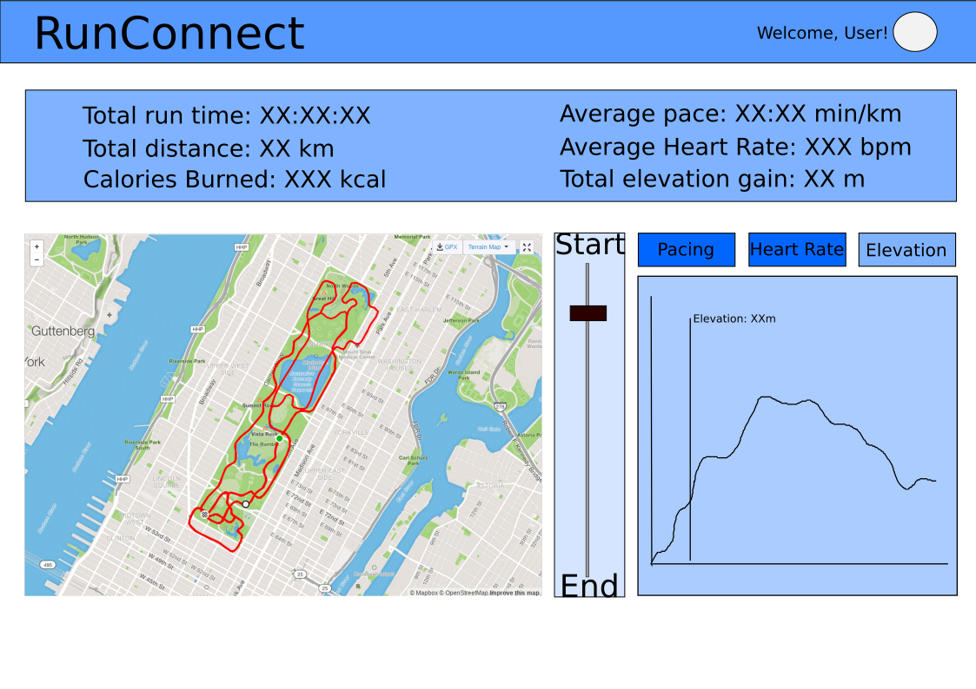

Daniel Colton

Daniel is 25-years-old and he works a nine-to-five desk job in front of a computer. He has recently started running in the mornings before work and he has taken a keen interest to it. Moreover, he is seeing the positive outcomes of a healthy lifestyle as a result of staying fit and spending time in the great outdoors.

Scenario 1
There is half a marathon in his neighbourhood that he wants to join. He wants to finish the event with a good total time and average pace, so he needs a utility to track his training rides so that he sticks to his exercise plan and can track his progress over time.

Scenario 2
He has joined a local running group and he is determined to become one of the fastest runners in the group. Thus, he needs a simple way to check his performance and progress compared to his runner buddies.

Bob Johnson



Bob is 27 years old and he currently stays with his parents while he is unemployed. He loves watching animation and usually spends all day at his room. Since Bob lacks regular exercise in his life, he started to become overweight. His parent convinced him to go outside regularly to do some exercise.

Scenario
Bob has decided to run across the city every day. Bob is now looking for a platform that can help him calculate how far he has run from home, how long he has taken, what is the average speed and the peak speed according to the GPX file provided. Bob also wants to know about how many calories he has burned during his workouts. To know how the effectiveness of his exercise, Bob wants to be able compare the data to the last few days data to know how he has improved and how much calories he has burned in total over the last week.

Nicole Grey


Nicole Grey is a 21-year-old full-time university student with a part-time job at a local fast food restaurant in Glasgow, Scotland. She heavily relies on the wage from her job and finds herself working 5 days a week on top of her studies, and so has very little time on her hands. She loves exploring nature and wants to exercise, so running is her favoured choice. She wants to make sure she is staying healthy so wants to record her running sessions and analyse them in a visual way.

Scenario 1
Nicole visited her doctor recently, who prescribed her to not push herself too hard while running. He suggested she should monitor her heart rate while running. Thus, she is worried about her physical health so she wants to make sure her heart rate and cadence is at a healthy level.

Scenario 2
Nicole’s university has recently organised a running race around campus. Nicole wishes to participate in this race and so wants to track her fitness gains and make sure she’s sticking to her training plan.

